**Project 4: Crowdfunding**

PART B Submission

1. Link to the GitHub Repository - <https://github.com/KritiBhardwaj/crowdfunding>
2. Link to the deployed project - <https://protected-beach-03173.herokuapp.com/>
3. Home Page – Crowd cultural exchange of photos

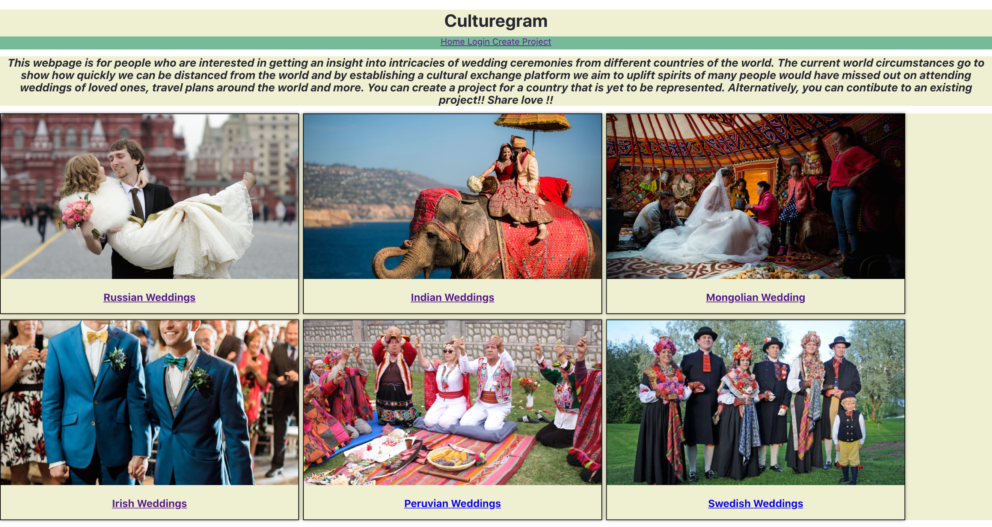

1. A screenshot of the project creation page

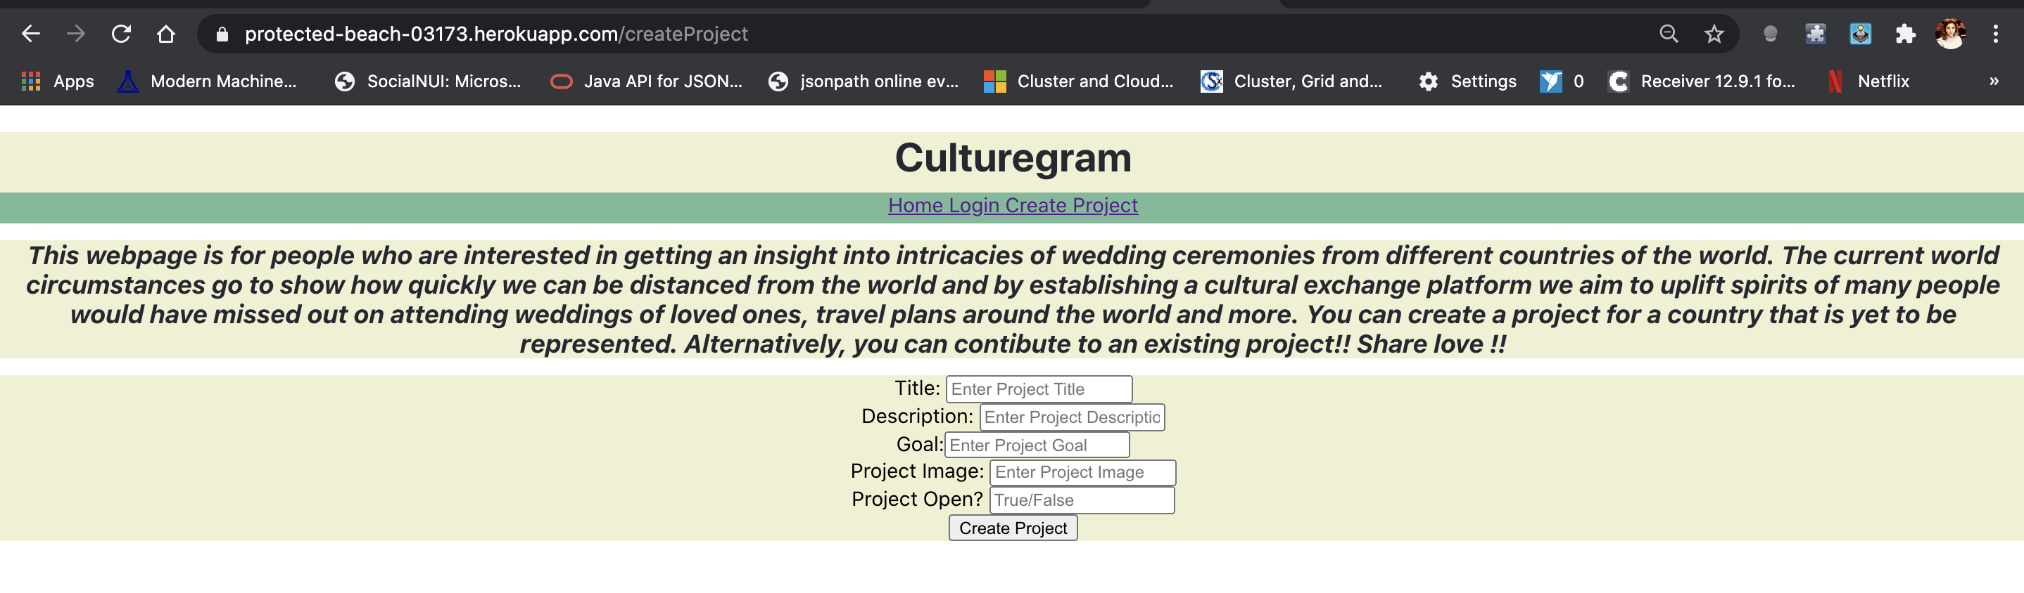

1. A screenshot of a project with pledges

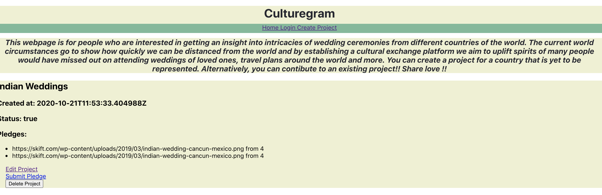

1. Customised 404 Page – Unauthorised Edit Project Error

